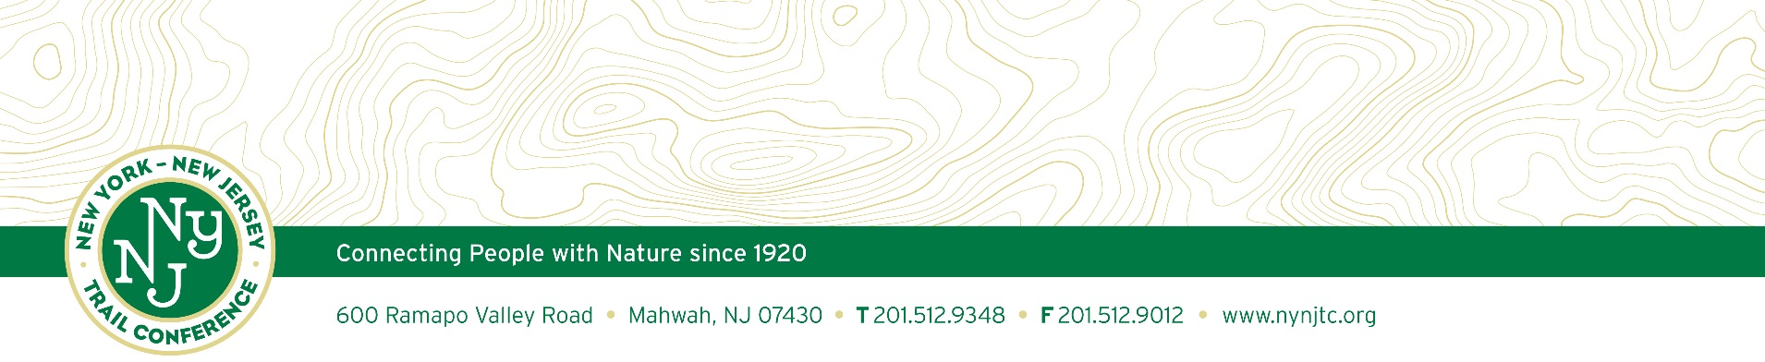

Dear Valued Customer:

The New York-New Jersey Trail Conference’s mission is to provide the public the opportunity to directly experience nature and, by doing so, help preserve the region’s environmental integrity. Protecting over 2,150 miles of trails from NYC and the Delaware Water Gap to Connecticut and the Catskills. Our organization is supported by nearly 10,000 members and 1,800 volunteers who donate over 100,000 hours of labor annually. Your support is vital to our mission as proceeds from your continued sales of our publications are used to further our organization’s work in the areas of land conservation, trail maintenance, environmental advocacy and irradiating invasive plants in the surround lands. Our mission to you is to provide the highest quality of customer satisfaction.

Product Return Guidelines

- All returns must be authorized by the orders department within 60 days of receipt. Please contact us at 201-512-9348 x811 or via e-mail gwillick@nynjtc.org.

- Damages must be reported upon receipt. Credit will not be issued otherwise.

- Maps/Books can only be returned if unused & in re-sellable condition.

- An invoice slip or original invoice number must be returned with the order.

- 15% restocking charge may be applied.

- Shipping and handling will not be refunded for returned merchandise, changed or cancelled orders.

- Once we receive your item(s) back, we will credit your account within 7 business days.

- 2% late fee monthly on overdue amounts.

- Credit will be issued for the previous edition of a map returned within 30 days of the release date of a new map edition. Returns between 30 and 60 days of the release date of the new edition will receive half credit (half the price paid for that map at last purchase time). A maximum of 50 items can be returned - any combination of items. The first 25 will receive full credit and the second 25 will receive half credit.

